**Dubai Based Fern Hospitality Ventures (FHV) Launches Fund To Raise An Initial $100m To Invest in High-Growth Global Hospitality Sector**

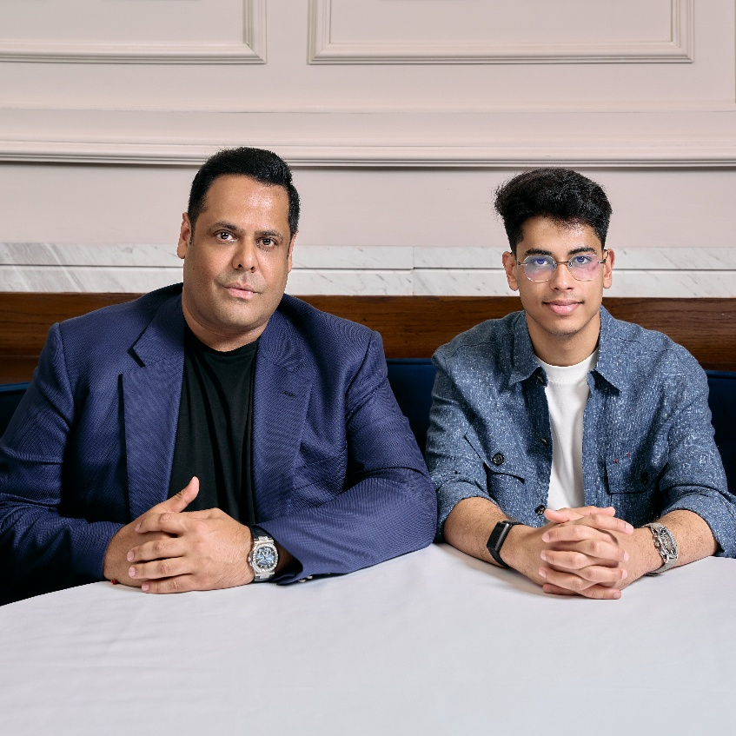

***“This is a once in a generation moment for hospitality investment,”* said Uday Singh, CEO of Fern Hospitality Ventures and the entrepreneur behind global successes like OPA and Bagatelle Dubai. *“Demand is soaring while supply remains limited. Our fund provides early access to the next generation of premium leisure and lifestyle concepts as they scale across the global social calendar that is driving demand from Dubai to New York, and London to Bali.”***

**The Fund**

* Raised $15m in first 24 hours of launching the fund
* FHV leverages Dubai’s hospitality success to scale brands worldwide as Dubai is becoming an exporter of globally renowned brands
* Fund is being created to give investors exposure to a global diverse range of hospitality growth prospects spanning all areas of the hospitality sector including technology led new concepts, luxury experiential brands and established brands in new emerging destinations
* This is the first of its kind investment fund that focuses on global luxury hospitality and f&b sectors while offering a dual return model that utilises cashflow from operations and the capital upside from real estate – targeting iconic venues/locations, sector disruptors and technology driven innovators
* Dalma Capital to manage Fern Hospitality Ventures, a closed ended fund, with a target fund size of $100m and targeting a net 20% return

**The Board**

Comprising hospitality sector investment gurus, and young talent in partnership with top operators globally. Experienced track record of successful investments.

* Uday Singh’s hospitality sector success includes Bagatelle Dubai and successful exit in 2022 and created subsequent new investor base.
  + Opa Dubai in 2018 and Opa, Mumbai in 2022 with growth plans in progress
  + Raising investment in opening of La Nina Dubai in 2023
* Akshat Tiberwala, Managing Director, in his early 20’s brings a young modern perspective and insight together with immediate assets included in the portfolio.
  + Set up private investment company Niyamo Capital in 2024 successfully leveraging lucrative funding to deploy in early-stage companies with high growth potential
    - Currently managing assets under management of $25m

**Portfolio post $15m fund raise**

* + Dorsia – a revolutionary tech driven reservations platform
  + 16 Charles Street, Mayfair – Private members club combining high-end dining concepts including the famed Loulou of Paris
  + Ramen Me – New wave consumer led Disco-dining concept successfully launched in Portugal
  + The Joyce – Miami based American dining
  + Opa, Bali – An experiential, Greek ‘Made in Dubai’ Concept that’s become a crowd favourite

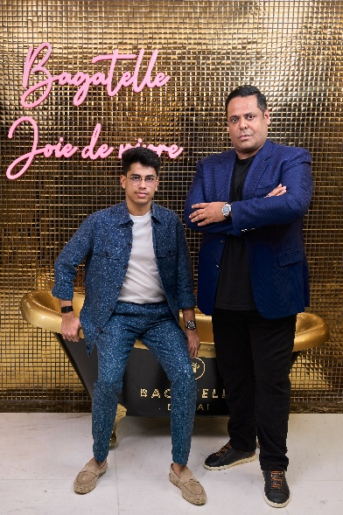In discussion with:

* + - A new ultra luxury wellness project created by one of the industry’s most famous wellness entrepreneurs.
    - Baoli, Bali - an encapsulating sunset to night destination breaking through Bali to cover the demand for a luxury beach club experience
    - Zumana, Bali – A prime beachfront destination that blends premium culinary experience with world class entertainment
    - Bang Cookies – social media, influencer led and scalable brand
    - Bagatelle – openings in new emerging locations

**Fund Strategy**

* Creating a diverse portfolio:
  + Backing early stage culturally relevant brands in food, wellness and experiential formats
  + Investing in disruptive technology
  + Investing in brands with high levels of social media influence
  + Scalable concepts that can be replicated across global trend driven destinations
    - Targeting brands with proven local traction and ability to expand into emerging hubs

**Rationale**

* Global luxury hospitality industry changed dramatically over last 5 years since Covid and is set to continue to change driven by the next generation, Emerging destinations and dining dominating the activities category for travel and tourism.
  + Spending in luxury hospitality expected to grow to $391B by 2028 from $239B in 2023
* The returns in this sector currently outperforming all other sectors and continue to be driven by dining being the No.1 consumer spend ahead of retail in the world. This is a fast growing and changing sector with new concepts, technologies and new tourist destinations emerging every year.

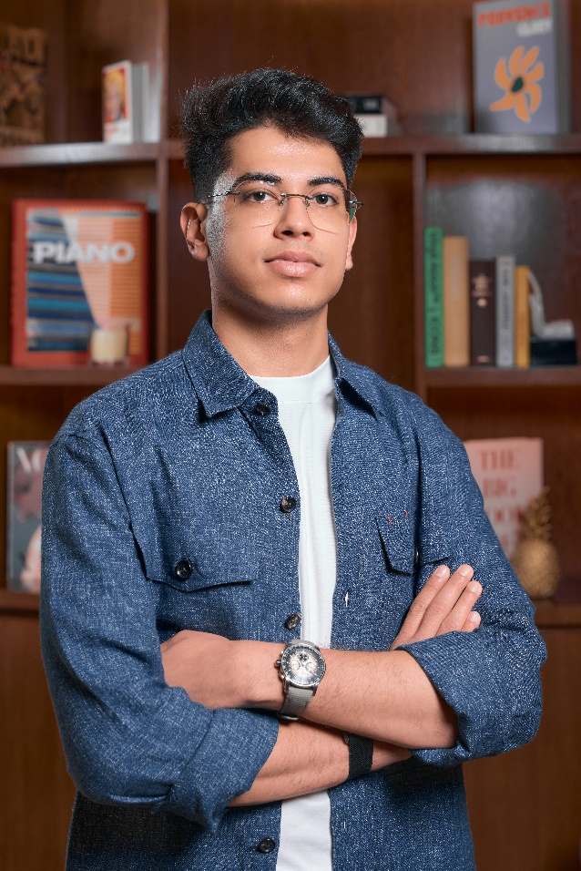***“We invest where global lifestyle trends meet real estate investment opportunity,” said Akshat Tiberwala, Managing Director at FHV. “We back cash-flow-positive brands with expansion-ready models and layer in technology to create scalable, efficient platforms. Our investments are not only about great concepts, but about systems that can grow globally.”***

***“Global Hospitality will increasingly be dominated by newer generations both as consumers and as operators through the rise of social media platforms. Brands are no longer growing linearly they’re growing laterally with the introduction of social media to the mix. We can see this as 71% young visitors use social media for restaurant updates and 73% visited restaurants in the last 3 months because of social media content.”***

**Dubai, UAE – Monday 25, 08, 2025** – Fern Hospitality Ventures (FHV), the Dubai-based investment platform focused on investing in world renowned brands on a long-term basis while providing annual return and eventual exit, has launched a $100 million fund targeting high-yield opportunities in the fast-evolving luxury hospitality and experiential leisure sector.

The fund’s line-up includes serial hospitality entrepreneur Uday Singh, who was behind the fund raising of award winning concepts like Opa, Bagatelle Dubai and La Nina, as well as Akshat Tiberwala one of the youngest entrepreneurs rooted in GenZ and is the Managing Director of private investment vehicle Niyamo Capital. The fund is managed by Dalma Capital, a leading DFSA-regulated investment firm.

Dubai’s position as a global powerhouse in luxury dining and hospitality continues to accelerate, with homegrown concepts now setting the benchmark for success on the world stage. Led by dynamic entrepreneurs including Uday Singh, whose portfolio has shaped the city’s high-end dining landscape, ‘Made in Dubai’ brands are not only dominating locally but also expanding into key international markets. The UAE has firmly established itself as one of the world’s core capitals for luxury dining, generating record revenues year after year and fostering the creation of innovative, scalable hospitality brands. As part of its strategy, Fern Hospitality Ventures will actively seek out brands that have proven themselves and are ready to take their concepts global.

This is the first of its kind investment fund that focuses on global luxury hospitality sectors while offering a dual return model that utilises cashflow from operations and value creation from global expansion – targeting iconic venues/locations, sector disruptors and technology driven innovators. The team also has a track record of achieving returns in excess of 30%. Now open to investors, the fund offers:

* 80% dividend distribution on operating income
* Exposure to iconic global brands in early-stage expansion
* Asset-backed investments with strong real estate fundamentals
* Dual-layer return strategy via operating income and capital appreciation on exit

There has never been a better time to set up a fund like this as fine dining guests demands surge together with the need for an immersive experience as well as trends such as ‘Revenge Dining’ becoming more popular. This has contributed to the growth of the fine dining market to go from $162B in 2020 to $253B in 2025. Core luxury hospitality sectors from Dubai to Miami and Bali show huge potential and has seen rapid growth over the last 5 years with record spend every year, yet operators are still lagging behind because of closures, capital restraints and ownership fragmentation. FHV, are closely monitoring each project and actively working with brands and operators to expand and create value.

Despite the great demand and growth in the Luxury hospitality sector, the technology is still in its early stages. With a dynamic strategy and an experienced team at the helm, the fund is built to capitalize on the next wave of growth in global lifestyle destinations. From culturally relevant F&B brands to digitally driven hospitality platforms, Fern’s portfolio is positioned at the convergence of rising tourism, real estate scarcity, and consumer demand for premium experiences.

**Editor’s Note**

1. **A Clear Strategy for a Changing Sector targeting global leisure hotspots**

The fund’s investment thesis is driven by fine dining being the top spending category within affluent travellers and is anchored in acquiring & scaling proven, high-margin concepts in the most in-demand hospitality hubs. With a strong initial pipeline and early-stage access to iconic brands, FHV gives investors exposure to new areas, new concepts and cutting-edge technology:

* **World-famous hospitality brands** expanding into emerging leisure destinations.
* **Culturally resonant concepts** in food, beach clubs, wellness, and members-only experiences.
* **Tech-powered disruptors** that leverage AI and digital platforms for demand forecasting, yield management, and curated guest experiences.

FHV's team brings together veteran operators, technologists, and real estate investors with a proven ability to unlock growth through operational precision and market insight.

* Dubai (UAE): Dubai’s luxury hospitality sector has reached new heights. 2023 was a record year, with Dubai welcoming 17.15 million international visitors (⇑19% YoY), finally surpassing its previous 2019 peak
* London (UK): London’s hotel industry suffered during COVID but has rebounded strongly, especially in the luxury tier. By 2023, performance had fully recovered and even exceeded historical norms.
* Bali (Indonesia): Bali’s luxury hospitality sector has not only rebounded but surpassed pre-pandemic performance.
* Mykonos (Greece): Mykonos – a marquee Aegean luxury hotspot – saw record tourism after reopening.
* Miami (USA): Miami’s hospitality market experienced a pandemic-era boom and has since stabilized at above 2019 performance.
* Tulum, a boutique luxury destination on Mexico’s Riviera Maya, has grown rapidly into a premium hotspot.

1. **GenZ : The future of hospitality**

* 79% dine out 5+ times per month.
* 88% follow travel influencers, turning TikTok and Instagram into the new booking engines.
* 89% of younger generations prioritizing travel as a top financial priority. This translates into frequent engagement: 79% dine out five or more times per month, significantly outpacing older generations.
* 52% prioritizing experiences over material possessions and allocating an average of 29% of their income to travel.
* 73% are willing to pay more for sustainable options.
* Experience beats ownership – 52% prioritise experiences over material goods.
* "snackification phenomenon" has created new opportunities for hospitality brands to engage consumers throughout the day rather than during traditional meal periods.

**The Digital Discovery Era**

* 74% of diners choose venues based on social content.
* TikTok videos under 30 seconds achieve double the completion rate of similar Instagram Reels.
* Yet fewer than **5%** of upscale restaurants use dynamic pricing or AI booking tools – leaving significant revenue untapped.

**Experiential & Immersive Formats on the Rise**

* Multi-sensory dining experiences, chef’s tables, themed events, and hyperlocal storytelling are becoming must-haves.
* Hybrid venues that combine dining with co-working, art, and wellness are capturing more guest touchpoints.
* Hotels offering unique dining concepts see 10% higher F&B revenues than traditional formats.

**Sustainability as Luxury’s New Status Symbol**  
Eco-responsibility, ethical sourcing, and community collaborations are now premium differentiators. The new ge values-first approach means operators that embed sustainability authentically into their brand DNA win loyalty and advocacy.

**Tech as the Next Hospitality Frontier**  
AI-driven demand forecasting, personalised guest journeys, and digital membership models like Dorsia are redefining exclusivity while driving operational efficiency.

1. **Growth Dynamics**

The fund is being created at a time when top tier leisure markets are enjoying record revenues and returns globally

* Fine market dining now valued at 28B Euros globally
* Culinary tourism is an $11B market growing at 20% a year
* The global luxury travel and tourism market is expected to reach $3 Trillion of revenue over the next five years
* Global spending on luxury leisure hospitality projected to grow to $391B by 2028 (2023 $239B)
* High Net Worth Individuals expected to double their spend from $80B to $154B over the next 3 years
* Guests travelling now stay longer and spend more on dining experience than hotels
* Global hospitality brands are emerging that combine fixed venues in cornerstone cities like New York or Dubai with global seasonal pop ups in destinations like St. Barts, Courchevel, St. Tropez and Mykonos
* Entertainment, experience and social cachet drive demand
* GenZ a key audience and by 2030 expected to account for 40% of global spending

**Bleisure and Digital Nomadism**

Bleisure travel (business-leisure combination) has exploded in popularity:

* 60% of corporate travelers extend trips for leisure
* Global bleisure market reached $430 billion in 2024
* Expected to reach $731.4 billion by 2032 (8.9% CAGR)
* 84% of travelers want to include vacation time in business trips

**High Res Images:**

[**https://drive.google.com/drive/folders/1zGPpYM19kdPN_794QhT-SQTCqZWCaKp5?usp=drive_link**](https://drive.google.com/drive/folders/1zGPpYM19kdPN_794QhT-SQTCqZWCaKp5?usp=drive_link)

**About Fern Hospitality Ventures**

Fern Hospitality Ventures is an investment platform based in Dubai, targeting premium hospitality, wellness, experiential F&B, and tech-driven lifestyle brands. Its focus is on scaling culturally relevant, real estate-backed assets in high-growth destinations across the globe.

**About Dalma Capital**

Dalma Capital is a leading global investment firm based in the Dubai International Financial Centre (DIFC) and regulated by the Dubai Financial Services Authority (DFSA). Managing over $10 billion in mandates, Dalma specializes in private equity, credit, and real assets.

**Media Enquiries**  
James Henderson | +971 50 471 4080 | james@JBH-PR.com  
Mohammad Aldaejy | +971 58 540 5177 | mohammed@JBH-PR.com